Email Agent- End-to-End Build Guide

Complete Documentation
Table of Contents

1. Introduction
- What is Email Agent?
- Problem Statement
- Solution

2. Generative AI
- Generative AI Overview
- Entity Extraction with AI
- Task Detection with AI

3. Technology Stack & Architecture
- Languages & Frameworks
- Key Libraries & Tools
- System Architecture
- Communication Flow

4. Requirements
- System Requirements
- Software Requirements

5. Step-by-Step Implementation
- PHASE 1: Install System Prerequisites
- PHASE 2: Setup Google Cloud Project
- PHASE 3: Setup Email Agent Application
- PHASE 4: System Testing

Introduction

What is Email Agent?
Email Agent is a fully autonomous AI-powered system that processes emails without human intervention using FREE local AI (Ollama). It reads emails from Gmail, analyzes intent using Llama 3, extracts entities (dates, times, attendees), creates calendar meetings automatically, generates tasks, and sends AI-generated replies confirming actions.

Problem Statement
- Manual Email Processing: Professionals spend hours daily reading emails, scheduling meetings, creating tasks, and sending follow-up responses.
- Context Switching: Constantly switching between email, calendar, and task management tools reduces productivity.
- Missed Actions: Important action items and meeting requests get buried in overflowing inboxes.
- Repetitive Work: Sending confirmation emails and scheduling meetings are repetitive tasks that consume valuable time.

Solution
Core Approach: Combine natural language processing, entity extraction, and large language models to automatically understand email intent and take appropriate actions without human intervention.
1. Entity Extractor Agent
- File: entity_extractor.py
- Class: EntityExtractor
- Initialized: Line 16 in app.py
What it does:
- Extracts dates (tomorrow, Monday, 12/25/2024)
- Extracts times (2pm, 14:00, 2:30 PM)
- Extracts duration (30 minutes, 1 hour)
2. Task Extractor Agent
- File: task_extractor.py
- Class: TaskExtractor
- Initialized: Line 17 in app.py
What it does:
- Identifies action items in email
- Extracts task title from sentences
- Determines task owner (who should do it)
3. Task Database Agent
- File: task_database.py
- Class: TaskDatabase
- Initialized: Line 18 in app.py
What it does:
- Creates SQLite database (tasks.db)
- Stores tasks with full metadat
- Retrieves tasks by ID or owner
- Updates task status/priority
4. Supervisor Agent
- File: supervisor_agent.py
- Class: SupervisorAgent
- Initialized: Line 19 in app.py
What it does:
- Validates meeting data (checks for missing dates/times)
- Validates tasks (checks for vague titles, past due dates)
- Validates calendar slots (ensures availability)
- Generates clarification questions
5. Calendar Slot Finder Agent
- File: slot_finder.py
- Class: CalendarSlotFinder
- Initialized: Line 177 in app.py (dynamically)
What it does:
- Finds available meeting slots
- Checks Google Calendar free/busy
- Proposes 3 time options
- Creates actual calendar events
6. Smart Reply Generator Agent
- File: reply_generator.py
- Class: SmartReplyGenerator
- Initialized: Line 20 in app.py
What it does:
- Generates professional email replies
- Includes meeting slots in response
- Lists task confirmations
7. Gmail/Calendar API Agent
- File: gmail_oauth.py
- Classes: GmailAPI, GoogleCalendarAPI
- Initialized: Line 13 in app.py (global), Line 174 (calendar)
What it does:
- Authenticates with Google OAuth
- Fetches emails from Gmai
- Sends emails via Gmail
- Checks calendar availability

Agent Connection Flow

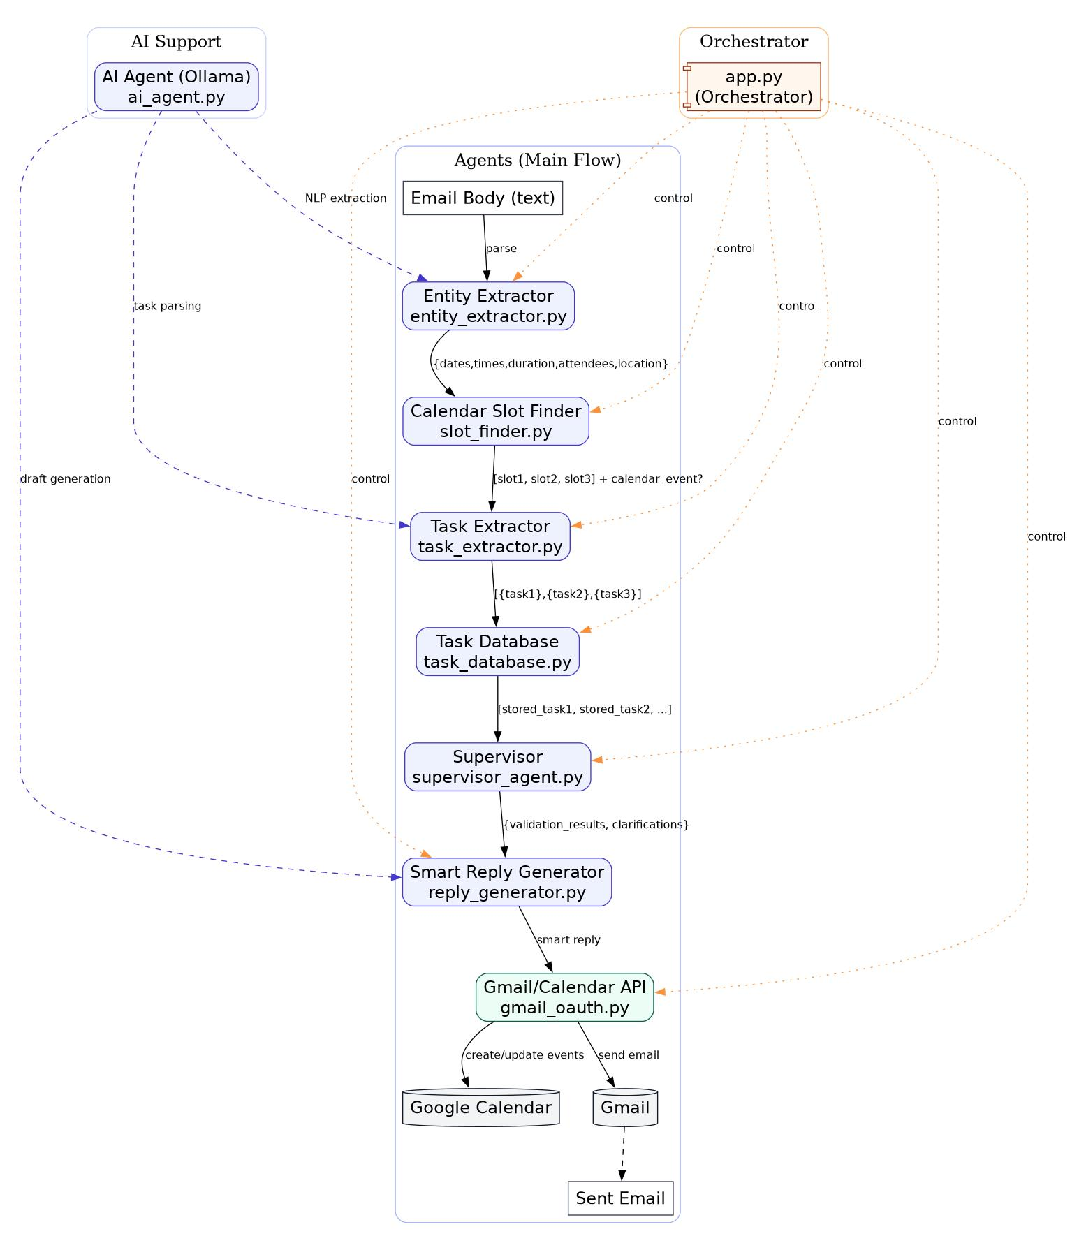

Generative AI

Generative AI Overview
Traditional AI focuses on classification and prediction (e.g., spam detection, sentiment analysis).
Generative AI learns patterns in data to create new content such as text, summaries, and responses.
Email Agent uses generative AI for:
- Understanding natural language in emails
- Extracting structured data from unstructured text
- Generating professional email replies
- Classifying email intent (meeting, task, question)

Entity Extraction with AI

What are Entities?
Entities are structured pieces of information extracted from unstructured email text:
- Dates: "tomorrow", "next Monday", "Jan 15th" → 2024-01-15
- Times: "2pm", "14:00", "afternoon" → 14:00
- Duration: "30 minutes", "1 hour", "quick call" → 30
- Attendees: Email addresses and names
- Location: "Zoom", "Conference Room A", "virtual"

How AI Extraction Works:
- Email body is sent to Llama 3 with structured prompt
- AI understands context and extracts entities in JSON format
- If AI fails, regex-based fallback extracts basic patterns
- Entities are validated and normalized

Task Detection with AI
Intelligent Task Identification:
- AI analyzes email content for action items
- Understands implicit tasks ("Please review the document" → task)
- Determines task owner (sender vs recipient)
- Assigns priority based on urgency keywords
- Extracts due dates from natural language

Technology Stack & Architecture
Developer Setup Guide - Required Software and Accounts

Languages & Frameworks
- Python 3.10+ - Core application logic and AI integration
- Flask - Web framework for UI and API endpoints
- HTML/CSS/JavaScript - Frontend interface

Key Libraries & Tools
- Ollama + Llama 3 - FREE local AI for entity extraction and reply generation
- Google Gmail API - Email reading and sending
- Google Calendar API - Meeting scheduling and slot finding
- python-dateutil - Date/time parsing and manipulation
- google-auth - OAuth2 authentication
- SQLite - Task database storage

System Architecture
Three-Layer Architecture:

Layer 1: USER (Gmail Inbox)

Layer 2: FRONTEND (Flask Web Interface) - http://localhost:3002
- Email list view (Inbox/Sent/Spam/Trash)
- Email detail view with AI processing
- Action results display

Layer 3: AI AGENT LAYER (Python Backend)
- Entity Extractor (AI + Regex)
- Task Extractor (AI + Regex)
- Reply Generator (AI + Template)
- Supervisor Agent (Orchestrator)
- Ollama AI (Llama 3) - http://localhost:11434

Layer 4: EXTERNAL SERVICES (APIs)
- Gmail API (Read/Send)
- Calendar API (Schedule)
- Task Database (SQLite)

Communication Flow
1. User Opens Web Interface → http://localhost:3002
2. Frontend Fetches Emails → Gmail API → Display in inbox
3. User Clicks "Process Email" → Triggers AI agent
4. Entity Extraction → AI analyzes email → Extracts dates/times/attendees
5. Intent Classification → AI determines: meeting/task/question
6. Action Execution: If Meeting: Calendar API → Find slots → Create event → Send invites
7. Action Execution: If Task: Extract action items → Store in database
8. Reply Generation → AI generates response → Gmail API sends reply
9. Results Display → Frontend shows actions taken

Requirements

System Requirements
- CPU: Modern multi-core processor (Intel i5/AMD Ryzen 5 or better)
- RAM: 8 GB minimum (16 GB recommended for Ollama)
- Storage: 10 GB free space (5 GB for Ollama models)
- OS: Windows 10/11, macOS 12+, or Ubuntu 20.04+
- Internet: Required for Gmail/Calendar API access

Software Requirements

Python 3.10+ (Core Application)
- Version: 3.10, 3.11, or 3.12
- What it is: Programming language for AI and automation
- Why needed: Run email agent and AI libraries
- Download: https://www.python.org/downloads/
- Verification: python --version (should show 3.10+)

Ollama (FREE Local AI)
- Version: Latest stable release
- What it is: Local AI runtime for running Llama 3
- Why needed: Entity extraction, task detection, reply generation
- Download: https://ollama.ai/download
- Model Download: ollama pull llama3 (4.7 GB)
- Verification: ollama list (should show llama3)

Google Cloud Project (Gmail & Calendar APIs)
- What it is: OAuth2 credentials for accessing Gmail and Calendar
- Why needed: Read emails, send replies, create calendar events
- Setup: See PHASE 2 below
- Cost: FREE (within Gmail API limits)

Step-by-Step Implementation

PHASE 1: Install System Prerequisites

Step 1: Install Python 3.10+
Windows:
- Go to https://www.python.org/downloads/
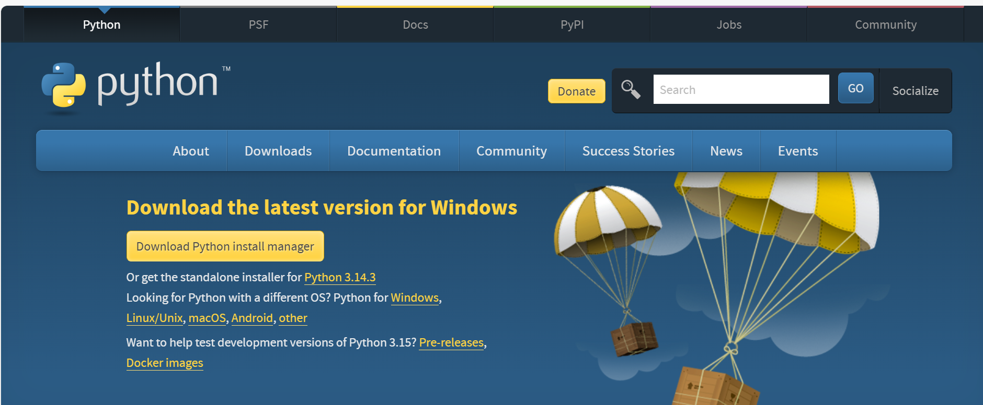

- Click "Download Python install manager”
- Run the installer
- Click "Install Now"
- Wait for installation to complete
- Open Command Prompt
- Type: python –version

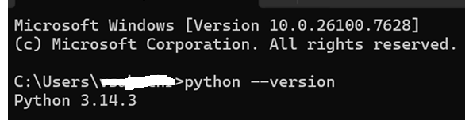s

- Should show: Python 3.10.x or higher

PHASE 2: Setup Google Cloud Project

Step 1: Create Google Cloud Project
- Go to: https://console.cloud.google.com/
- Sign in with your Google account
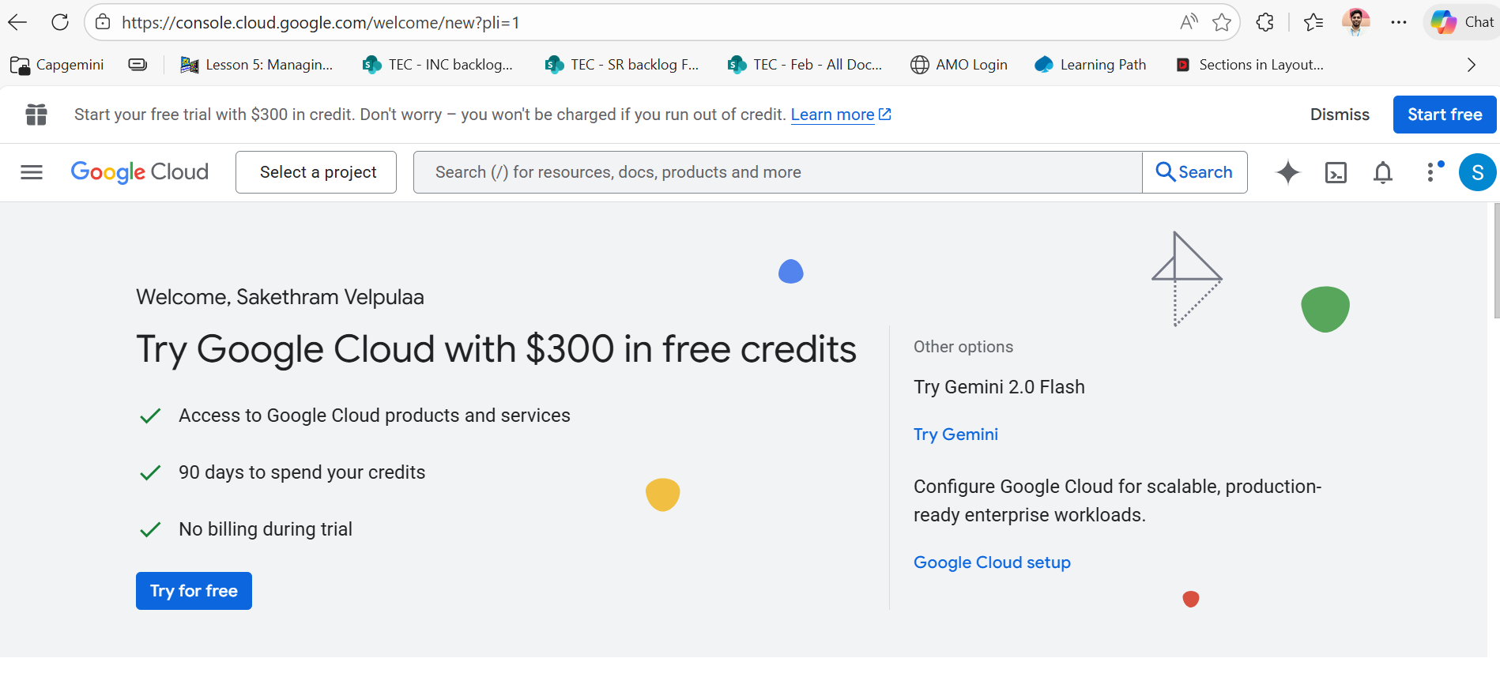

- Click "Select a project" → "New Project"
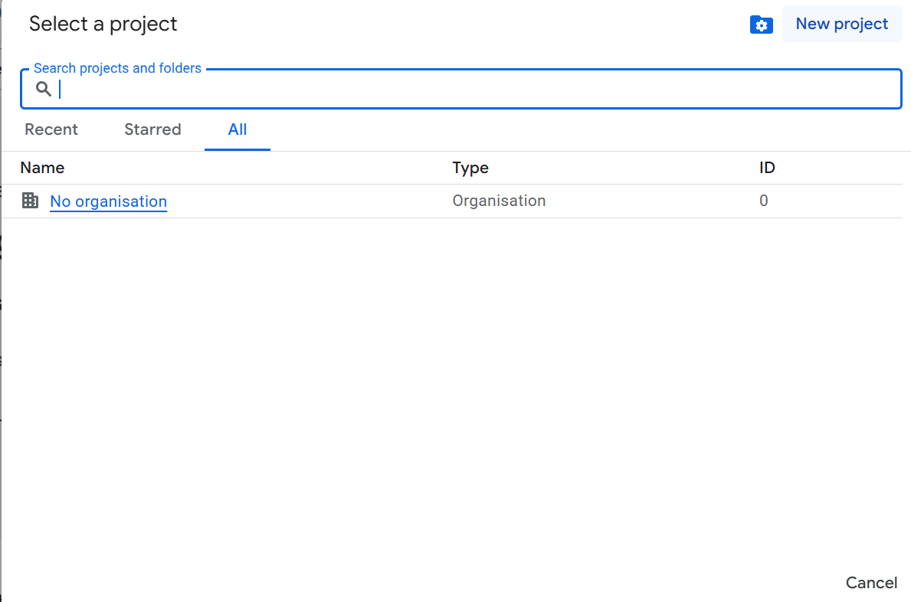

- Enter project name: Email-Agent
- Click "Create"
- Wait for project creation (30 seconds)
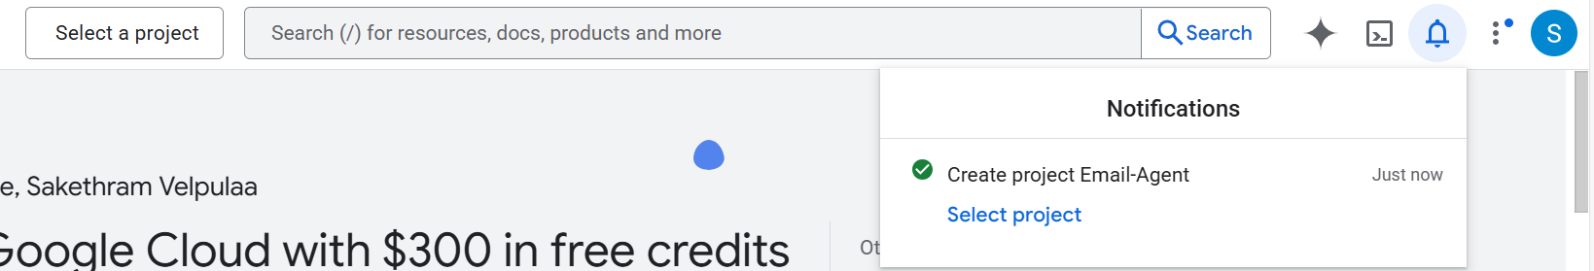

Step 2: Enable Gmail API
- In Google Cloud Console, click "APIs & Services" → "Library"
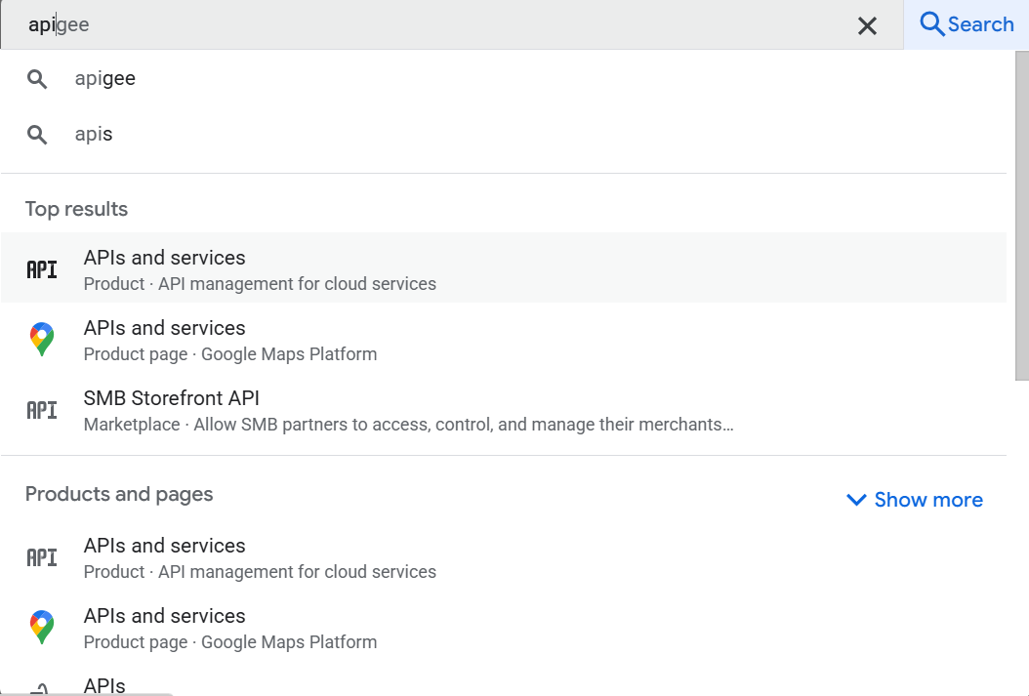

- Search for "Gmail API"
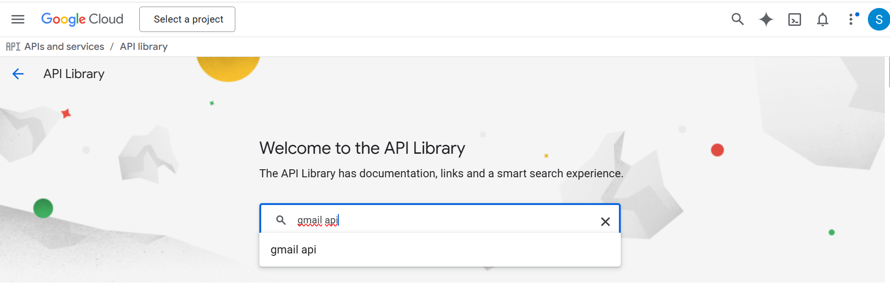

- Click "Gmail API"
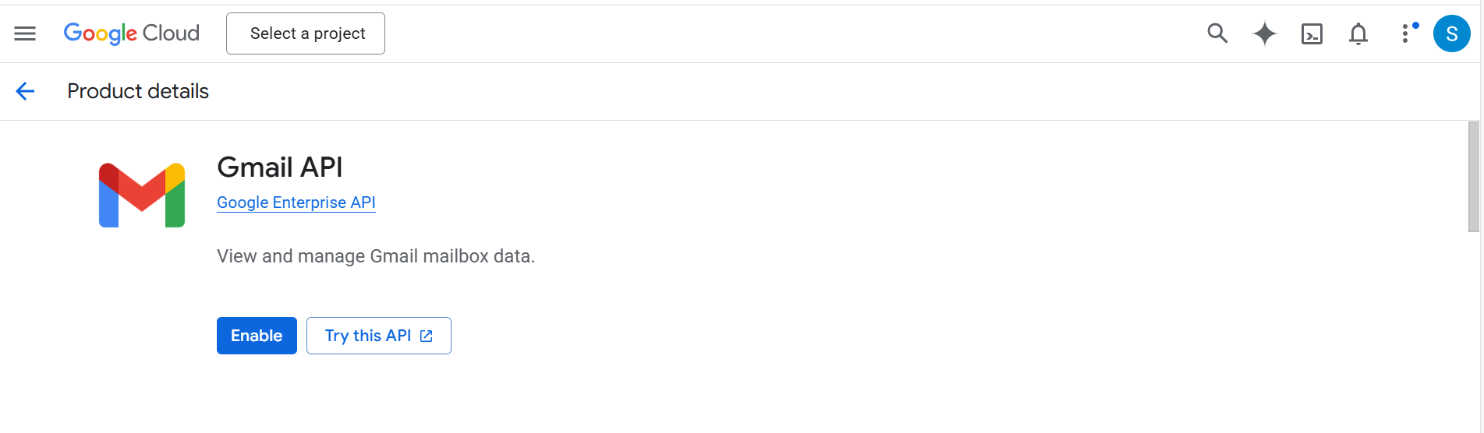

- Click "Enable"
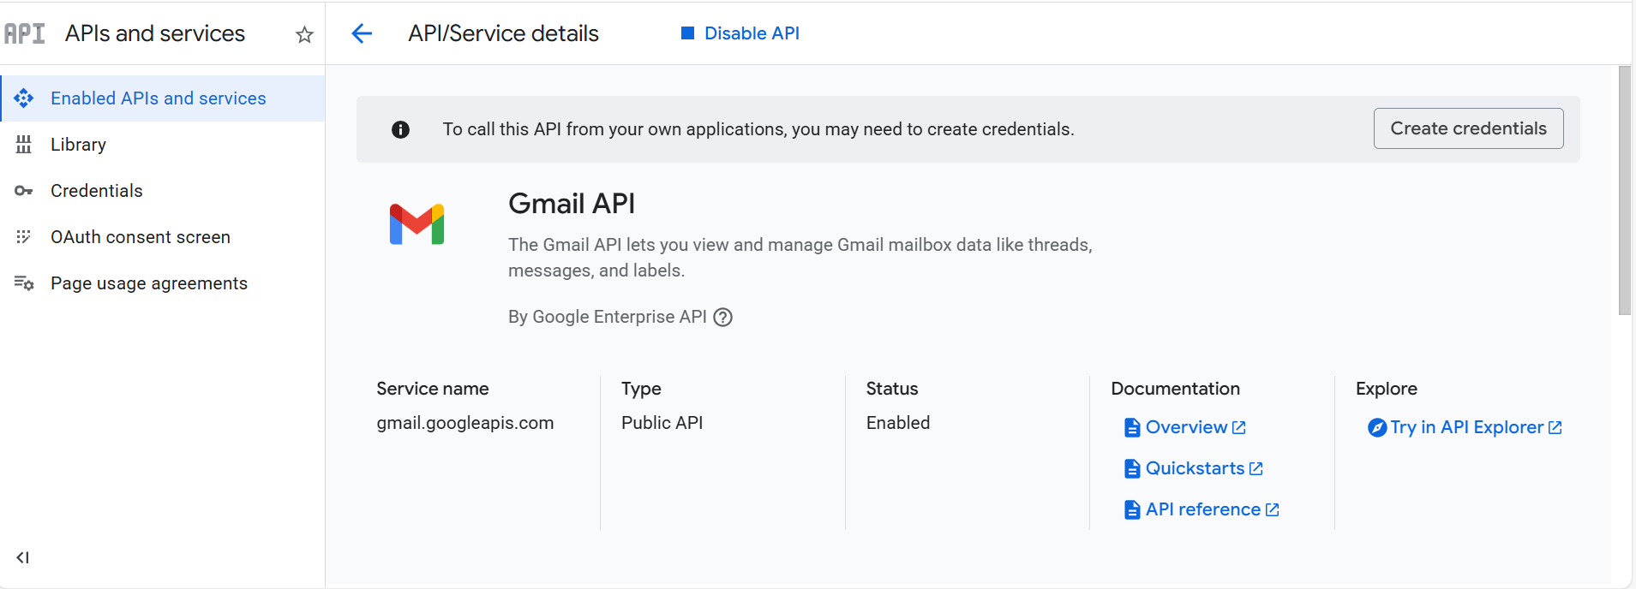

- Wait for activation

Step 3: Enable Google Calendar API
- Click "APIs & Services" → "Library"
- Search for "Google Calendar API"
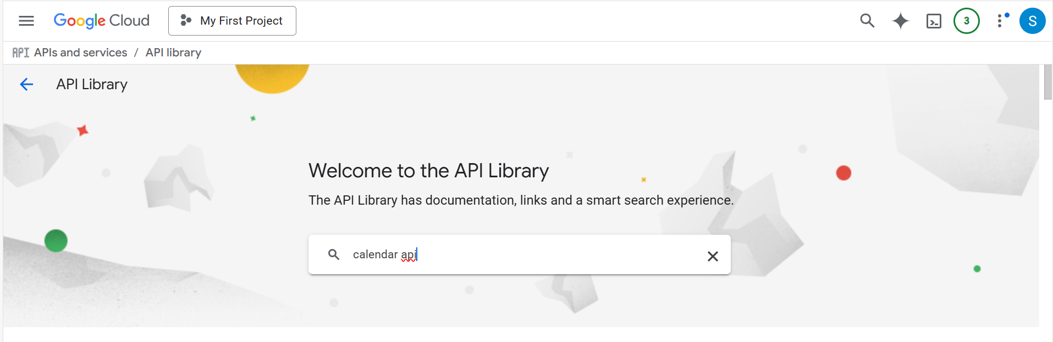

- Click "Google Calendar API"
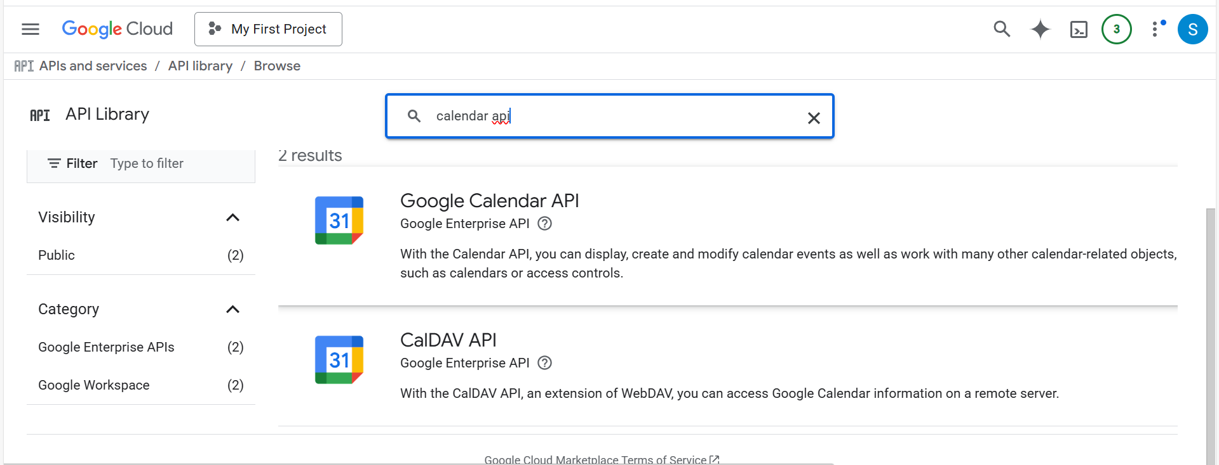

- Click "Enable"
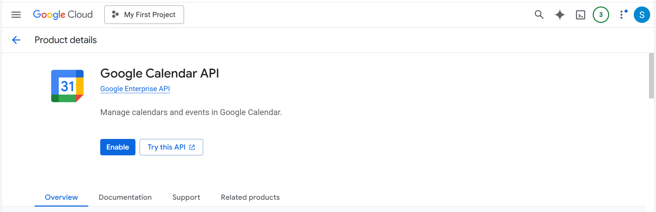

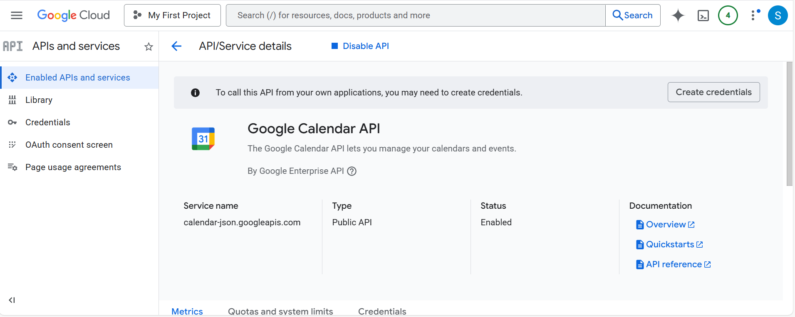

Step 4: Create OAuth2 Credentials
- Click "APIs & Services" → " OAuth consent screen "
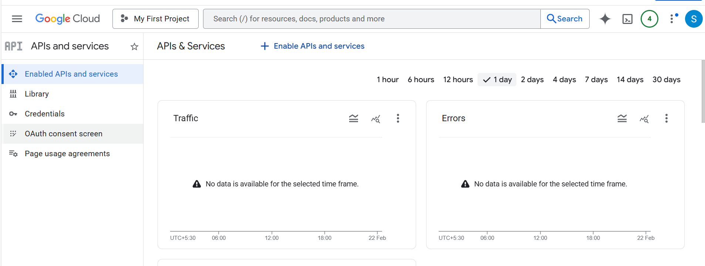
- Click "Branding" → "Get started"→You will find app information
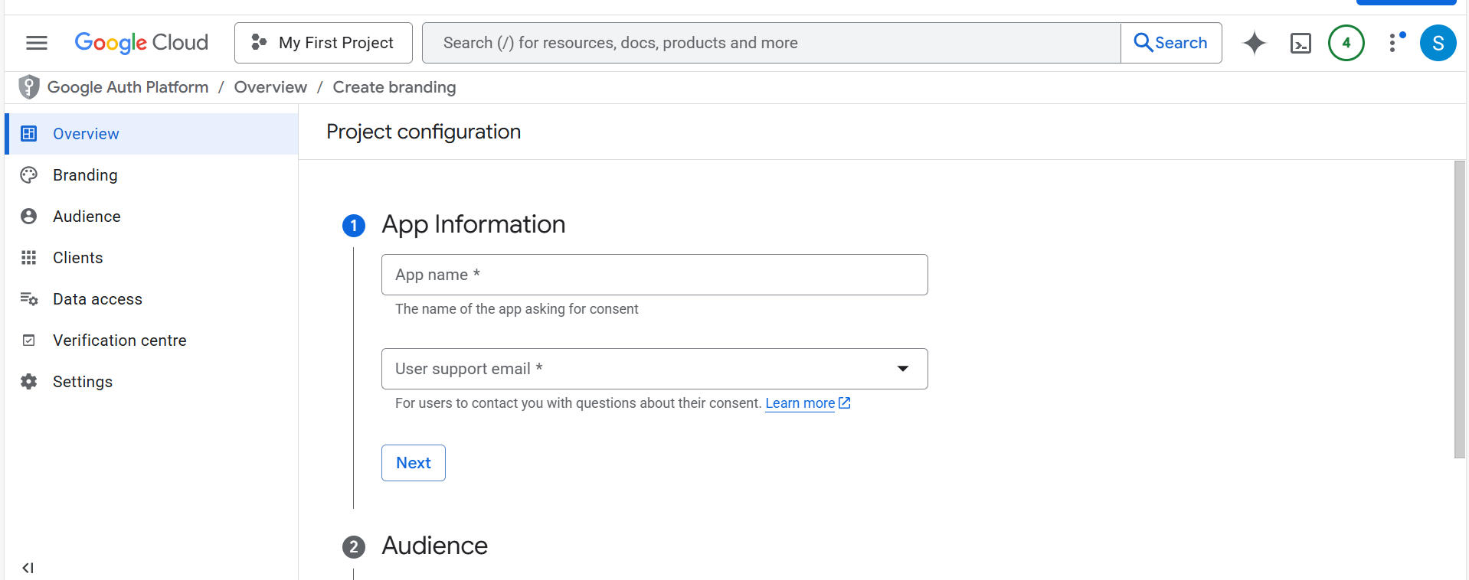

- “Add Email Agent as an App name and respective email address” -> Click next

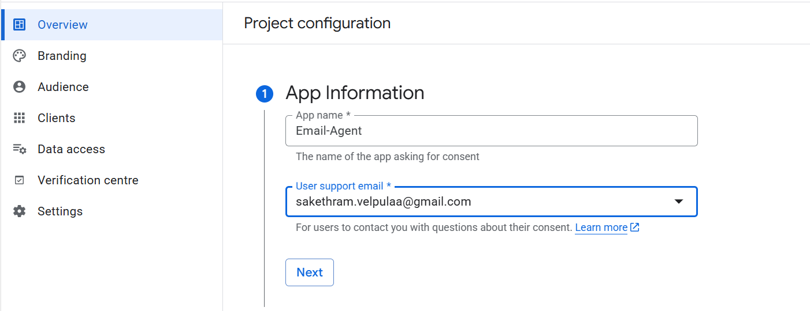
s

Add Audience as External -> Click next

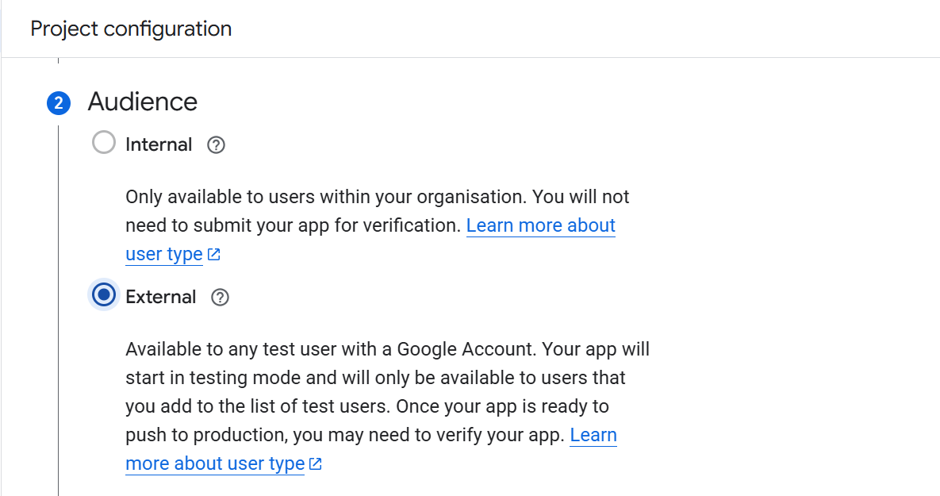

Add Contact Information as respective email address -> Click next

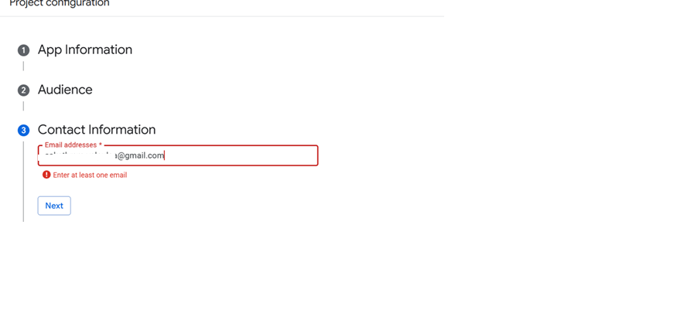

Click on I agree and continue to create

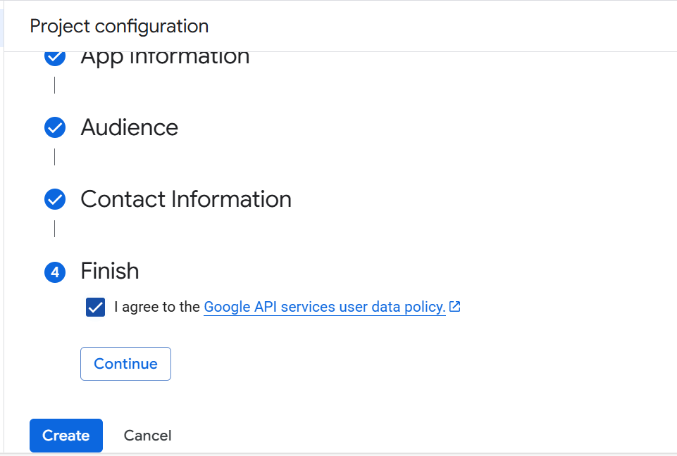

Click on Audience on same page -> Scroll down to find Test users -> Click add users-> Enter the respective email address and click on save.

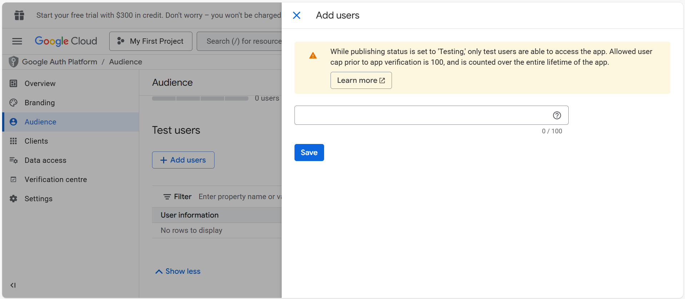

Click on save again

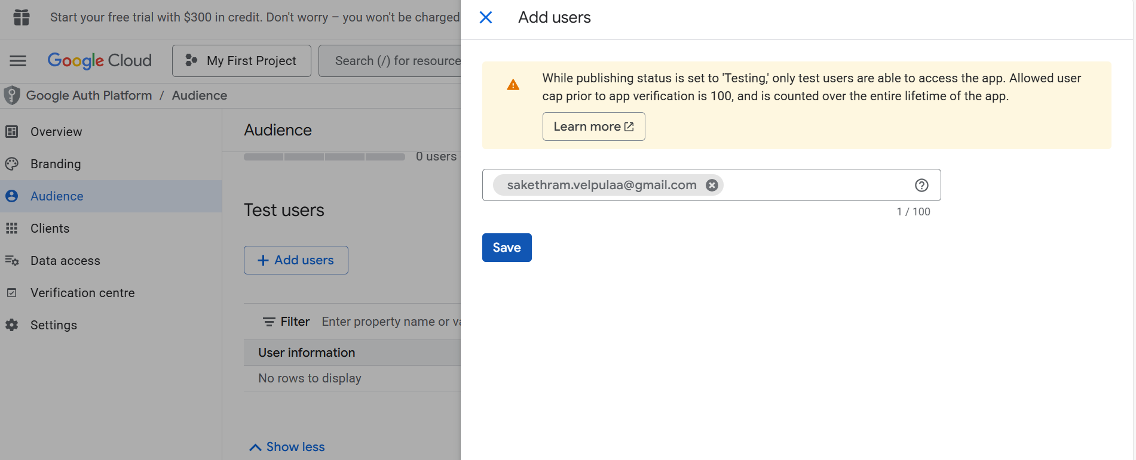

You will find yours Email address in user information

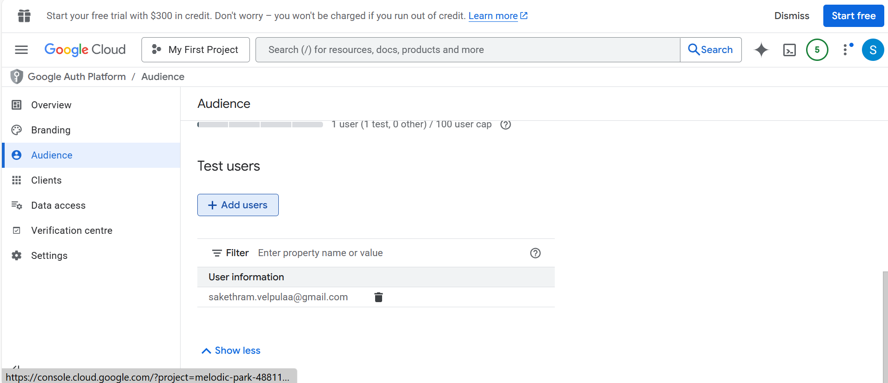

Click on Audience again you will find Publishing status as Testing and User type as External

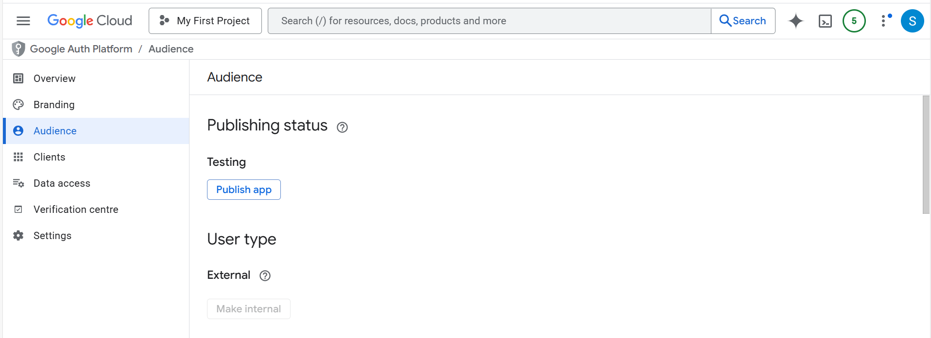
Now click on Clients on same page -> Click on Create Client

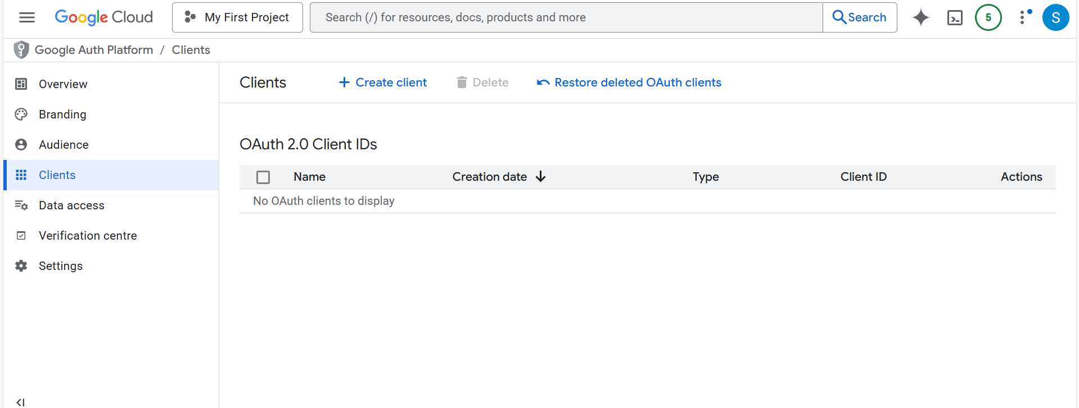

Now set Application type as Web application

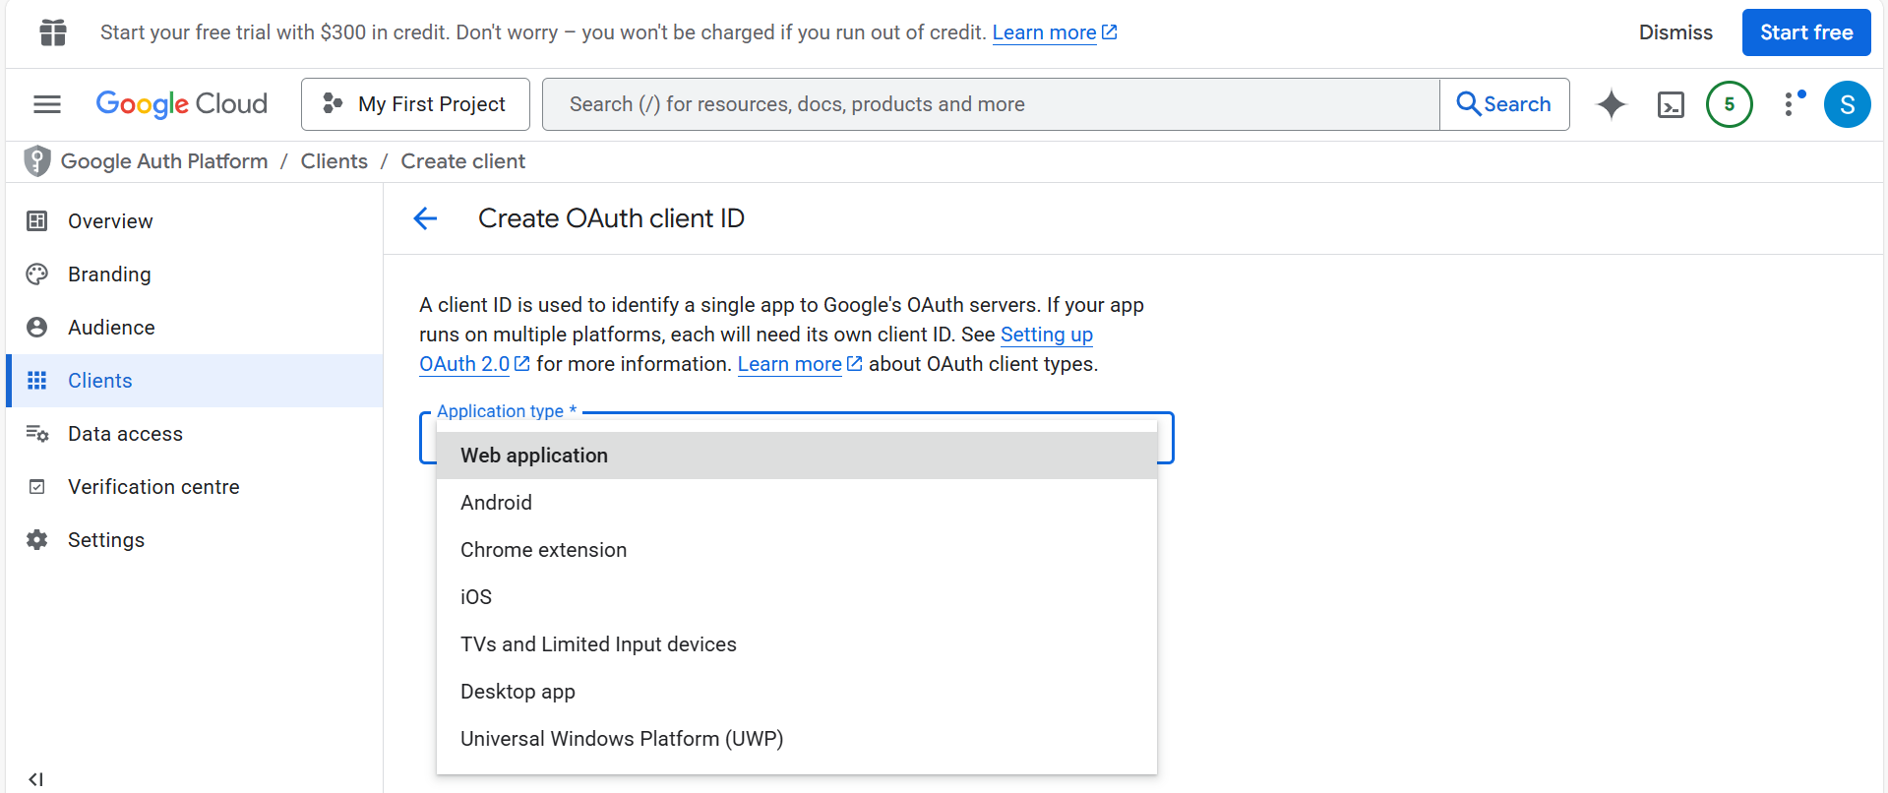

Scroll down and you will find Authorised redirect URIs

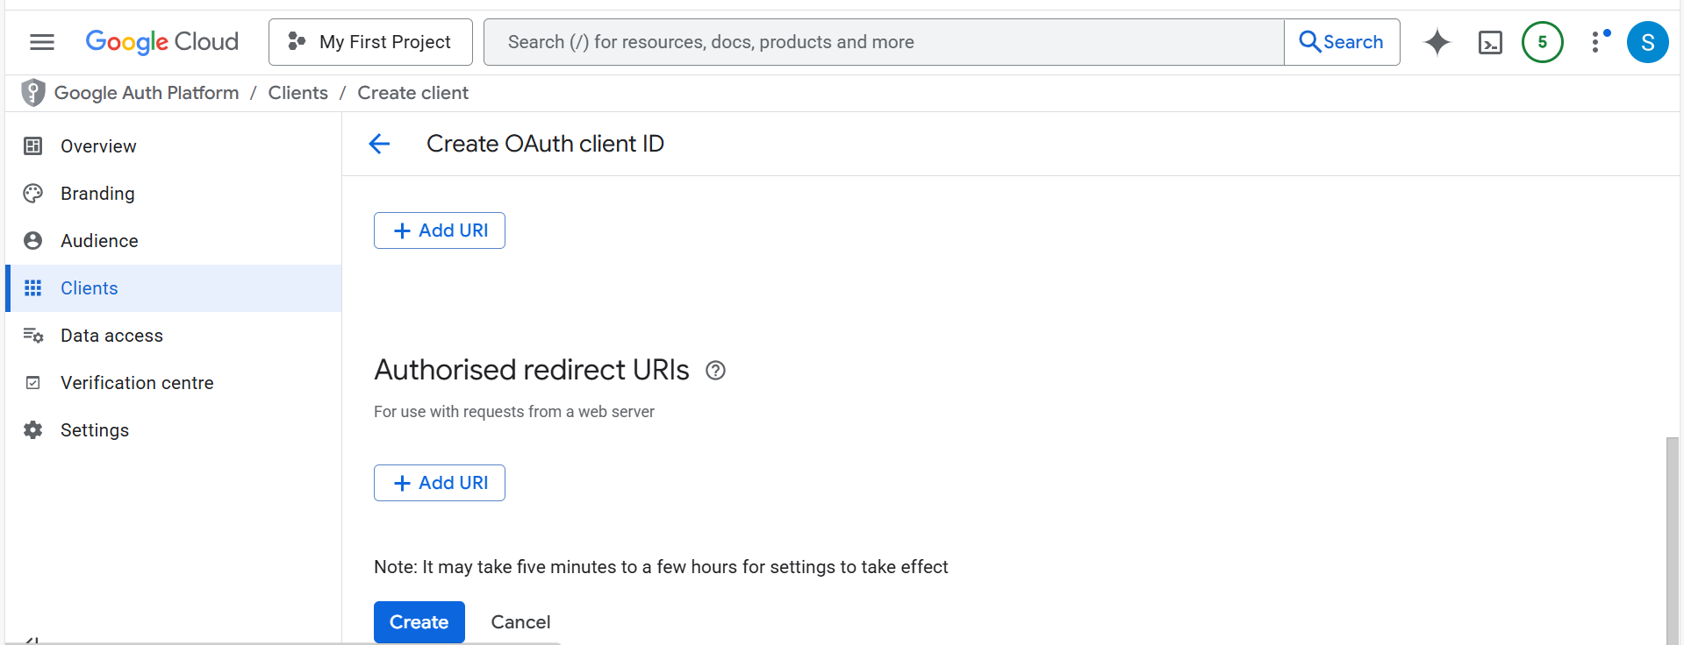
Now add URI as http://localhost:8080/ and click create

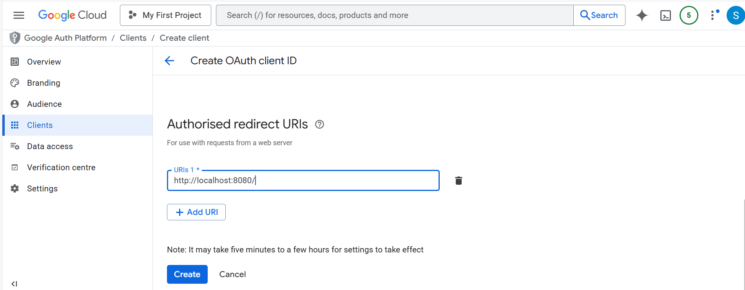

After creating you will find OAuth client created -> Download JSON File -> Rename the file name to “credentials”

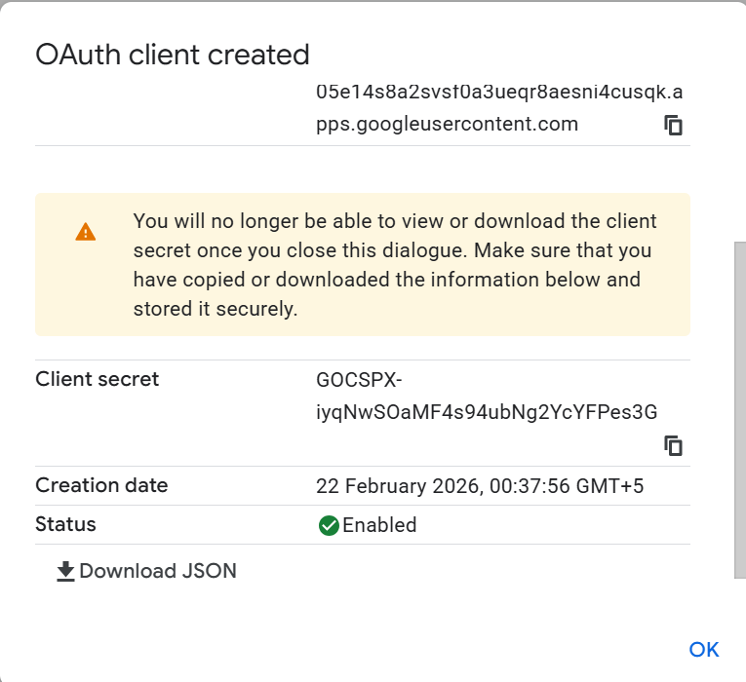
The JSON File is downloaded successfully

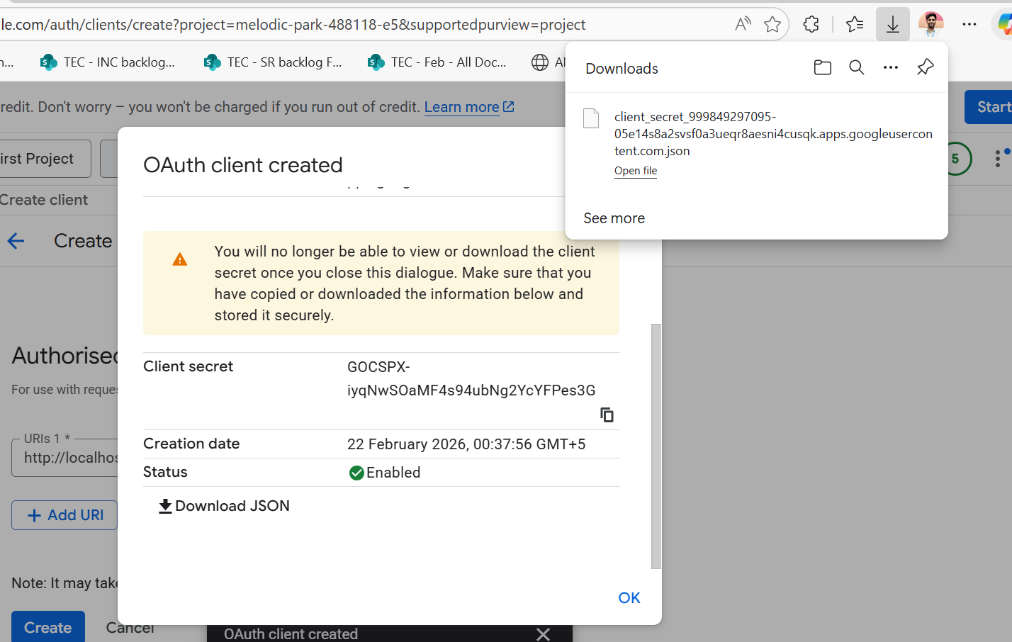

Now you can find a Client Id as shown below

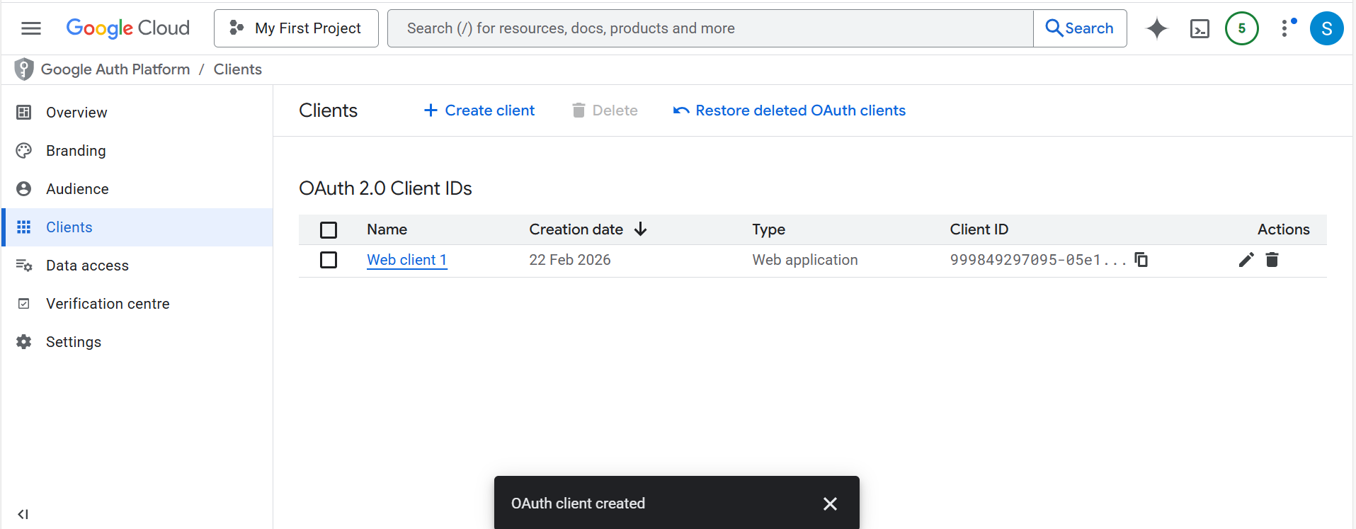

PHASE 3: Setup Email Agent Application

Step 1: Steps to create Email Automation Agent
Prompts to create the application:-
Core Setup Prompts (1-5)
- "Create a Flask web application with Gmail OAuth2 authentication using google-auth-oauthlib. Include GmailAPI class with methods to authenticate, fetch emails, and send replies. Use token.pickle for credential storage and port 8080 for OAuth callback."
- "Create a GoogleCalendarAPI class that integrates with Google Calendar API v3. Include methods to find free/busy slots, create calendar events with attendees, and query upcoming meetings for the next 30 days."
- "Build an EntityExtractor class that uses regex and AI (Ollama) to extract dates, times, duration, location, and attendees from email text. Support natural language date parsing like 'tomorrow', 'next week', 'Monday at 3pm'."
- "Create a TaskExtractor class with AI integration (Ollama) that identifies action items and tasks from email content. Extract task title, owner, due date, priority (high/medium/low), and description. Store tasks in SQLite database."
- "Implement a TaskDatabase class using SQLite with CRUD operations for tasks. Include fields: id, title, description, owner, due_date, priority, status, email_id, created_at. Add methods: create_task, get_all_tasks, update_task, delete_task."
AI Integration Prompts (6-8)
- "Create an OllamaAI class that connects to local Ollama service on port 11434. Include methods: complete(prompt), extract_json(response), and enabled property. Use llama3.2 model with fallback to regex if Ollama is unavailable."
- "Build a SupervisorAgent class that validates meeting data (dates, times, attendees) and task data (owner, due dates). Generate clarification questions when information is missing or ambiguous."
- "Create a SmartReplyGenerator class using AI to generate contextual email replies. Include meeting confirmations with proposed slots, task acknowledgments, and compose drafts based on subject line. Support both AI-generated and template-based replies."
Calendar & Scheduling Prompts (9-10)
- "Implement a CalendarSlotFinder class that finds available meeting slots by checking Google Calendar free/busy times. Propose 3 alternative slots based on extracted dates/times, default to business hours (9 AM - 5 PM), and create calendar events with attendees."
- "Add calendar event creation functionality that automatically schedules meetings in the first available slot, sends invites to attendees, includes location if specified, and returns calendar event link."
Flask API Endpoints Prompts (11-15)
- "Create Flask REST API with endpoints: GET /api/emails?folder=inbox (fetch emails from Gmail with folders: inbox, sent, spam, trash), POST /api/process (process email with AI to extract entities, tasks, schedule meetings, and send smart reply)."
- "Add Flask endpoints: GET /api/tasks (retrieve all tasks from database), GET /api/scheduled-meetings (fetch upcoming calendar events for next 30 days), POST /api/compose (generate AI draft email), POST /api/send (send composed email via Gmail)."
- "Implement email processing workflow: 1) Extract entities and classify intent (meeting/task/other) using AI, 2) Find calendar slots if meeting detected, 3) Extract and store tasks in database, 4) Validate data with supervisor, 5) Generate and send smart reply automatically."
- "Create automatic meeting scheduling: When meeting request detected, find 3 available slots, create calendar event for first slot, send invites to attendees, include alternative slots in reply email, and return calendar link."
- "Build email classification using AI: Analyze email subject and body to determine intent (meeting/task/question/other) and urgency (high/medium/low). Use Ollama AI with JSON response format, fallback to keyword matching if AI unavailable."
Frontend UI Prompts (16-18)
- "Create a modern responsive HTML/CSS/JavaScript frontend (demo.html) with three-column layout: sidebar with folders (Inbox, Sent, Scheduled, Spam, Trash) showing counts, middle panel displaying email list, right panel showing AI processing results and automated actions."
- "Add email compose modal with floating action button. Include fields for To, Subject, and auto-generate email body using AI based on subject. Show draft preview before sending. Use purple gradient theme (#667eea to #764ba2)."
- "Display AI analysis results with color-coded cards: blue for analysis (intent, entities, tasks found), orange for extracted entities (dates, times, location), green for automated actions (meetings scheduled, tasks created, replies sent), red for clarifications needed."
Configuration & Setup Prompts (19-20)
- "Create requirements.txt with dependencies: Flask, google-auth-oauthlib, google-api-python-client, python-dateutil, ollama (optional). Add credentials.json template for Google OAuth with redirect_uri http://localhost:8080/. Run Flask app on port 3002."
- "Add comprehensive error handling: OAuth redirect_uri_mismatch errors, missing credentials.json, Ollama connection failures with regex fallback, Gmail API quota limits, Calendar API permission errors, and database connection issues. Log all errors with traceback."
Bonus Advanced Prompts
- "Implement scheduled meetings view that fetches and displays upcoming calendar events with summary, attendees (show first 3 + count), start time, and clickable calendar link. Handle all-day events and recurring events."
- "Add real-time email processing with loading spinners, success/error notifications, email preview truncation (200 chars), HTML escaping for security, and active state highlighting for selected emails."

Step-1: Open the Folder
- Open Terminal/Command Prompt
- Navigate to desired location:
- Navigate into folder: cd email-agent

Step 2: Add Google Credentials
- Replace recently downloaded credentials file (from PHASE 2, Step 4) into email-agent folder
- Verify file location: email-agent/credentials.json

Step 3: Install Python Dependencies
- Run the command in desired location in vs code : pip install -r requirements.txt
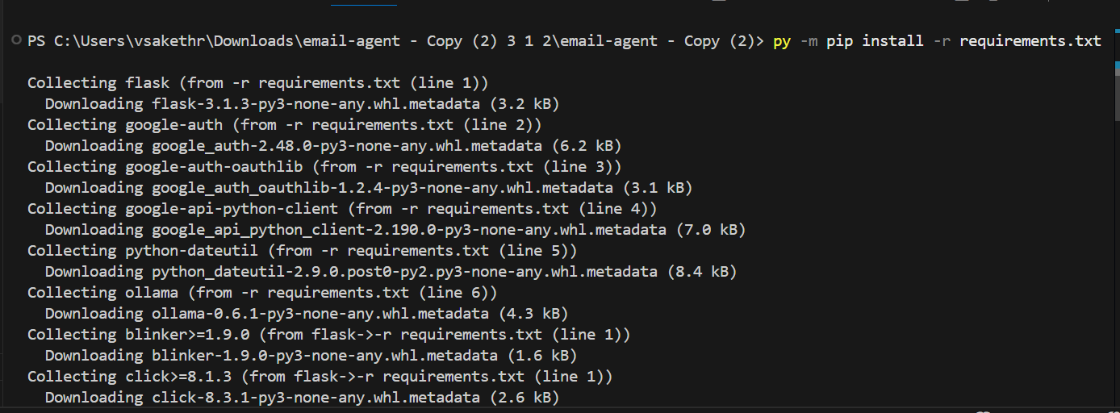
- Wait for installation (1-2 minutes)
- Should show: "Successfully installed..." for all packages
- Run the command in vscode : del token.pickle

PHASE 4: System Testing

Test 1: Run Email Agent Application
- Run: python app.py

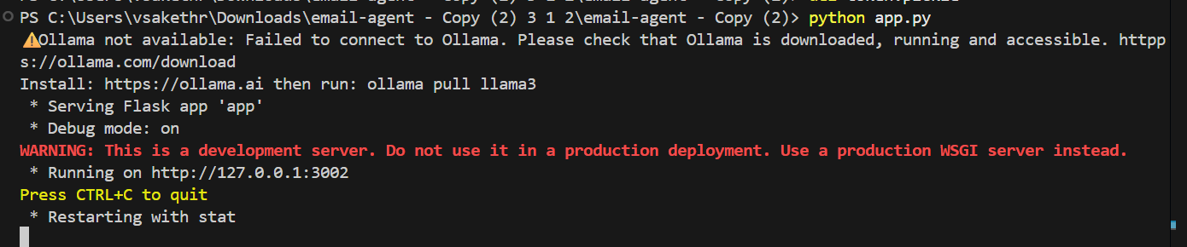

- Should show: * Running on http://127.0.0.1:3002 -> it will redirect to authentication page -> click on your respective email

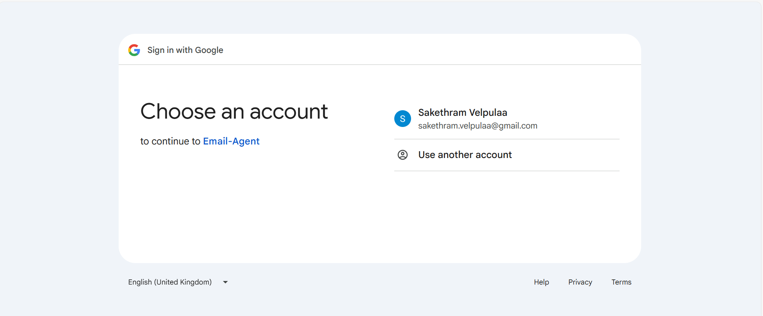
s

Now click on select all and continue

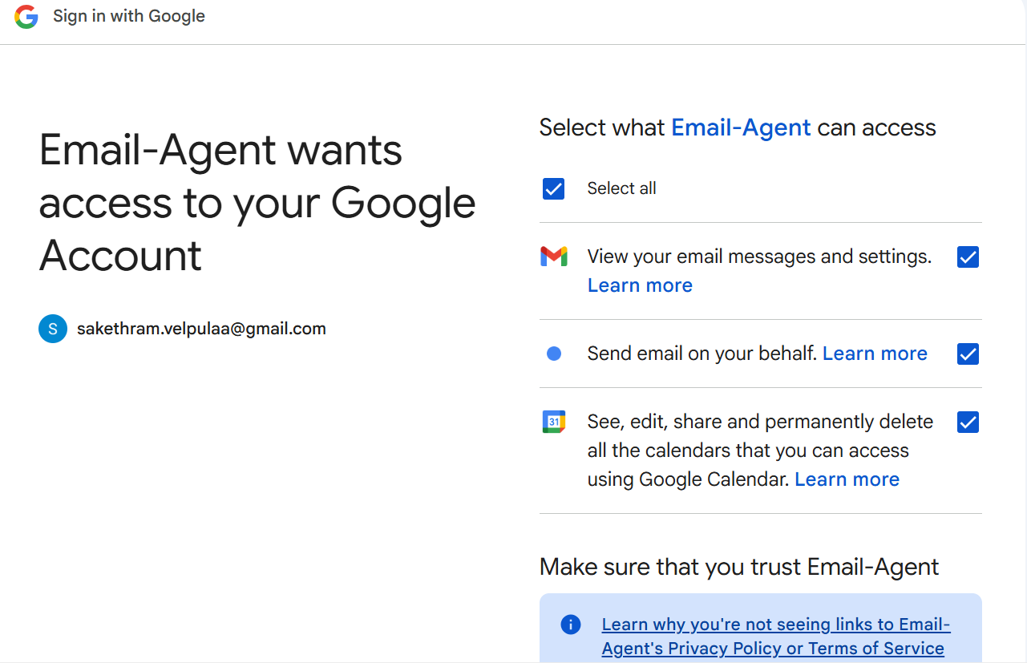

- Leave this terminal running

Test 2: Open Web Interface
- Open web browser
- Go to: http://localhost:3002
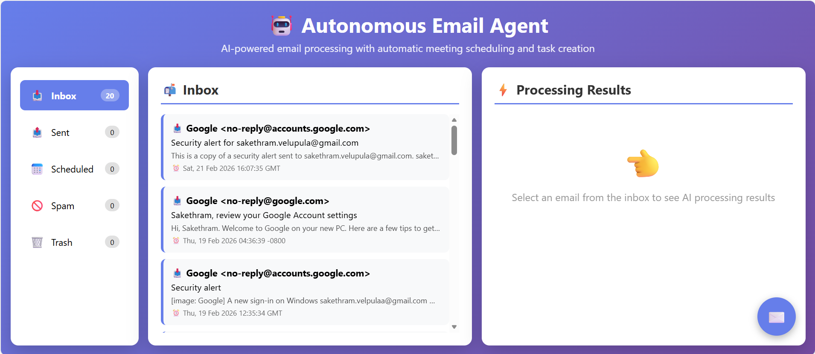

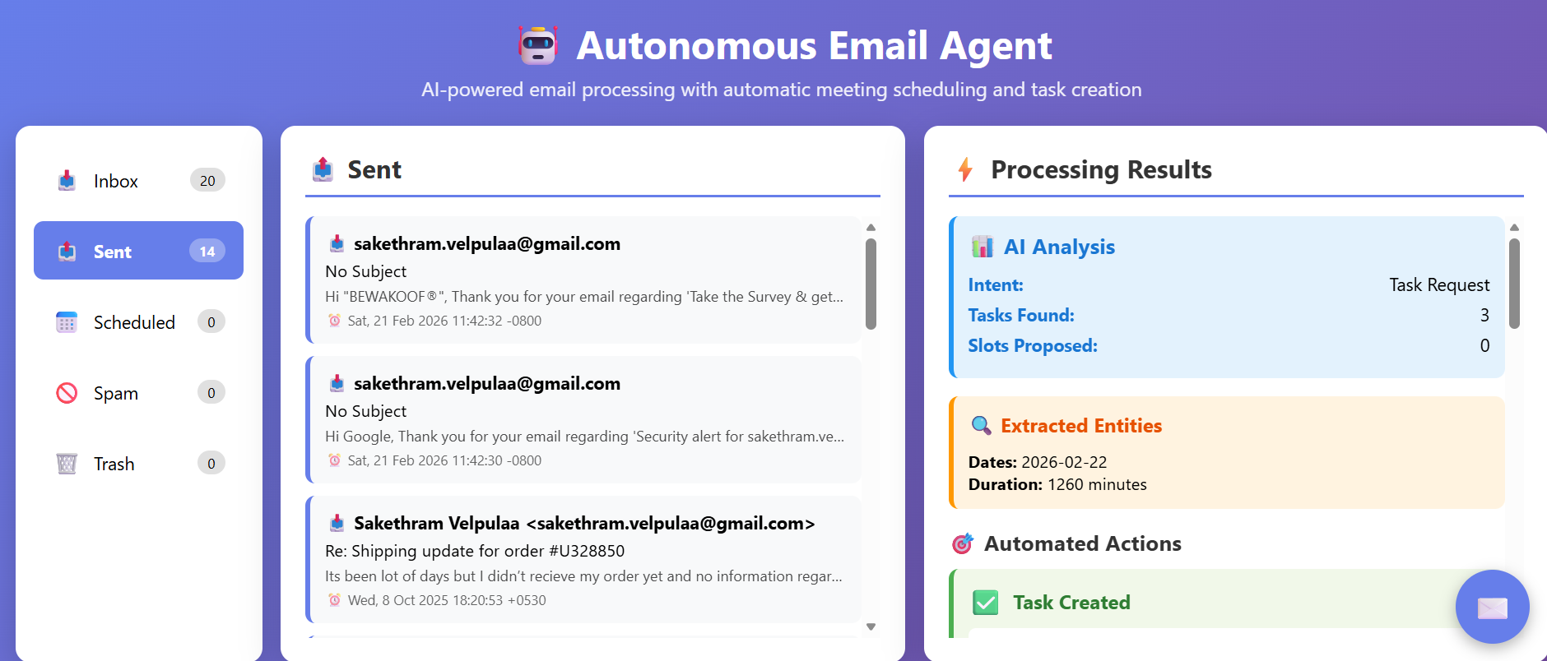

- Should see Email Agent interface with Inbox/Sent/Spam/Trash tabs

Test 6: Process a Test Email
Send yourself a test email with content: "Can we schedule a meeting tomorrow at 2pm for 30 minutes to discuss the project?"
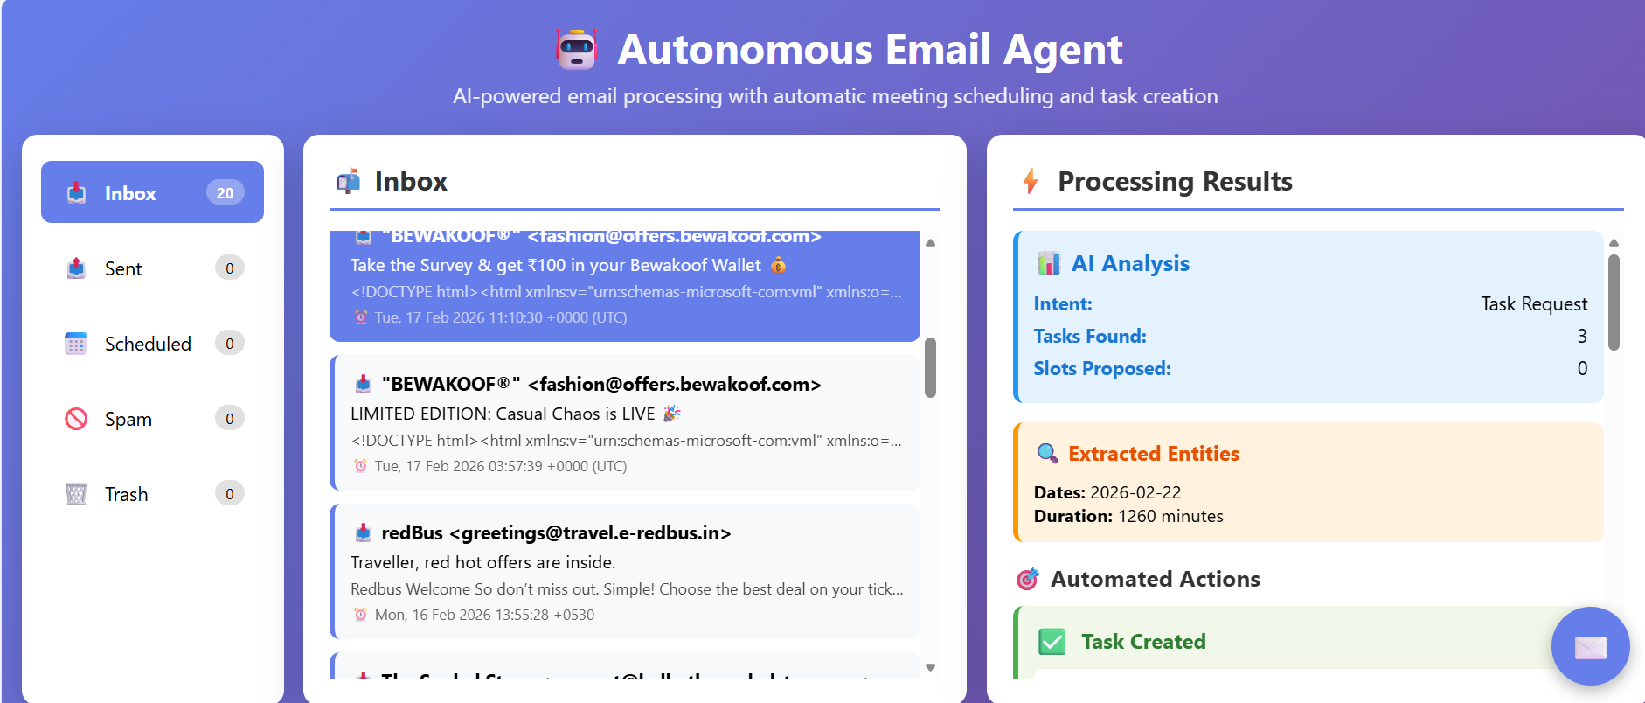
- In Email Agent interface, click "Refresh"
- Click on the test email
- Click "Process with AI" button
- Wait 5-10 seconds
- Should show: ✅ Processing Complete
- Should show: 📅 Meeting Scheduled with time and details
- Should show: ✉️ Reply Sent

Test 7: Verify Calendar Event
- Open Google Calendar: https://calendar.google.com
- Check tomorrow's date
- Should see new event at 2:00 PM
- Event should include title, time (2:00 PM - 2:30 PM), and attendee

Test 8: Verify Reply Email
- Check sender's inbox
- Should receive reply email from your Gmail
- Reply should contain confirmation of meeting time and calendar event details

Troubleshooting

Issue: "credentials.json not found"
Solution:
- Verify file exists in email-agent root folder
- If missing, re-download from Google Cloud Console
- Ensure file is named exactly: credentials.json

Issue: "Gmail API quota exceeded"
Solution:
- Gmail API has daily limits (free tier: 1 billion quota units/day)
- Each email read = ~5 units, send = ~100 units
- Wait 24 hours for quota reset
- Or upgrade to paid tier in Google Cloud Console

Issue: "Port 3002 already in use"
Solution: Stop other application using port 3002, or change port in app.py to 3003

Support & Resources
- Documentation: See README.md for quick start
- Ollama Setup: See OLLAMA_SETUP.md for detailed AI setup
- Gmail API: https://developers.google.com/gmail/api
- Calendar API: https://developers.google.com/calendar/api
- Ollama Docs: https://ollama.ai/docs

Version: 1.0
Last Updated: February 26

License: MIT

